Service Bulletin
No. 91-003
q Optional TIMELINE VISTA, INC.
1755 la costa meadows drive
q Recommended san marcos, CA 92069
Tel. 760-761-4440
q Mandatory (FAX 760-761-4449)
SUPPORT@DIGAUDIO.COM

Keyboard Control Unit Hardware Upgrade

DATE: 07/30/26

MODEL: Lynx Keyboard Control Unit (KCU)

REVISION: All

SERIAL NO: N/A (Software version specific)

SOFTWARE: KCU080-14 and higher

REQUIRED TOOLS:
Static safe workstation Phillips screwdriver
Grounding wrist strap X-acto knife
Soldering Iron 30 AWG Wire

DESCRIPTION:
When the Keyboard Control Unit (KCU) is used with Lynx-2 modules, or KCU080-14 or higher software is installed, the KCU processor board must be modified for the KCU to operate correctly. Failure to perform this modification will cause operational errors.

PROCEDURE:
1. Turn off the power to the KCU power supply unit. Disconnect all cables.
2. Place the KCU on a static safe workstation. Ground yourself and the workstation anti-static mat.
3. Remove the two phillips screws holding the PROM cover to the chassis. Remove the cover by lifting up, out and sideways.
Figure 1. Remove the PROM Cover

PROCEDURE (continued)
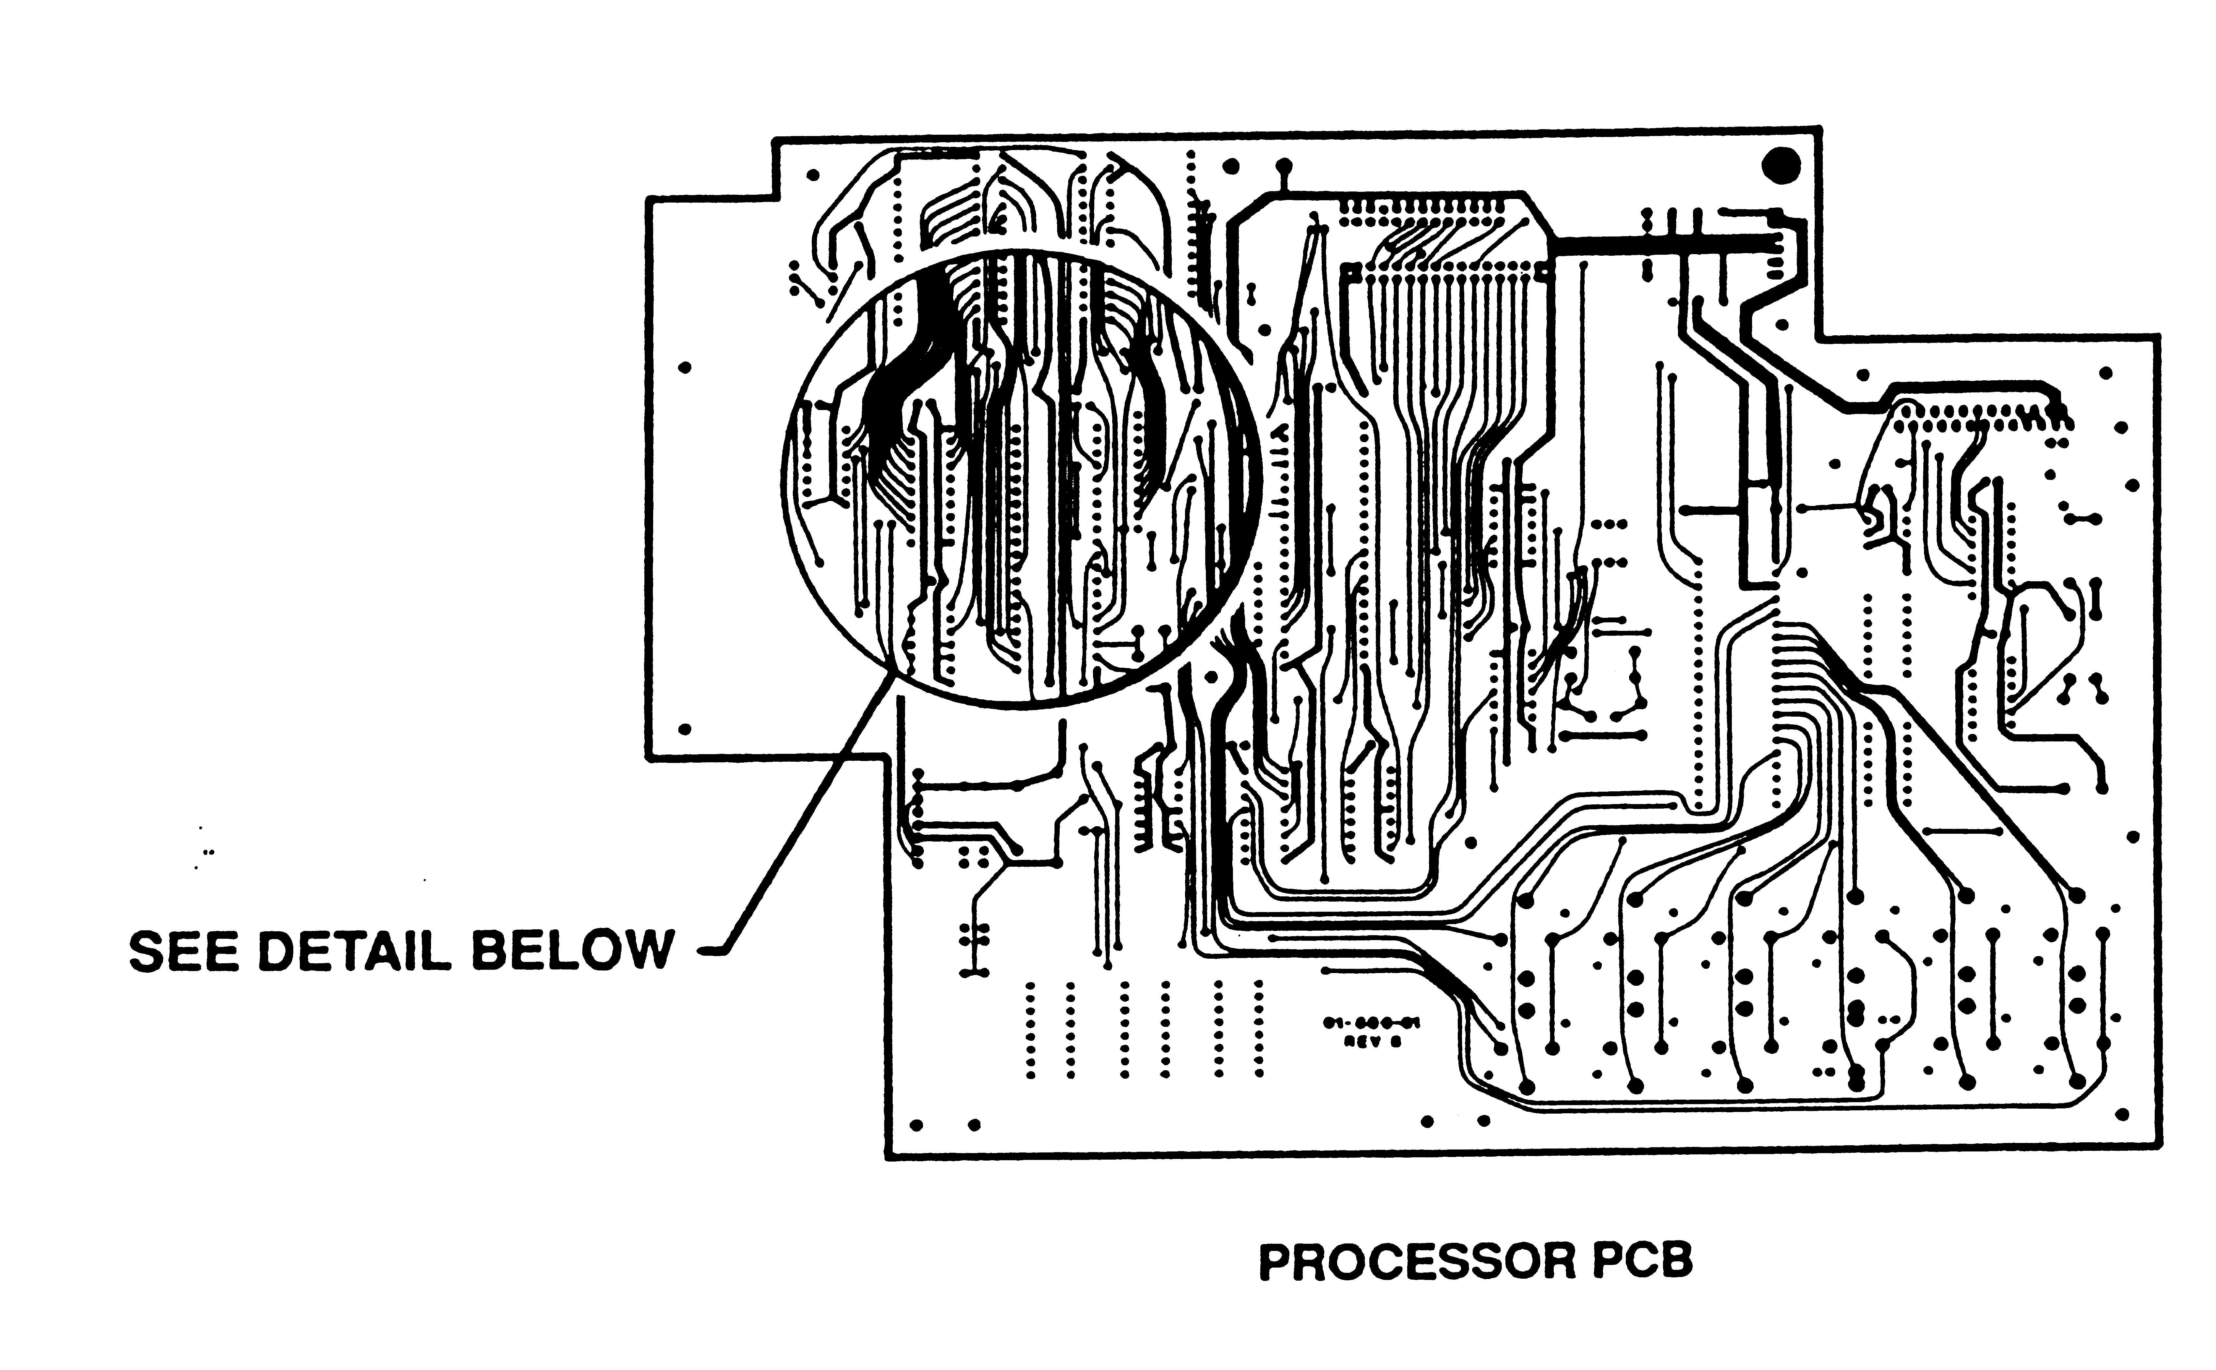
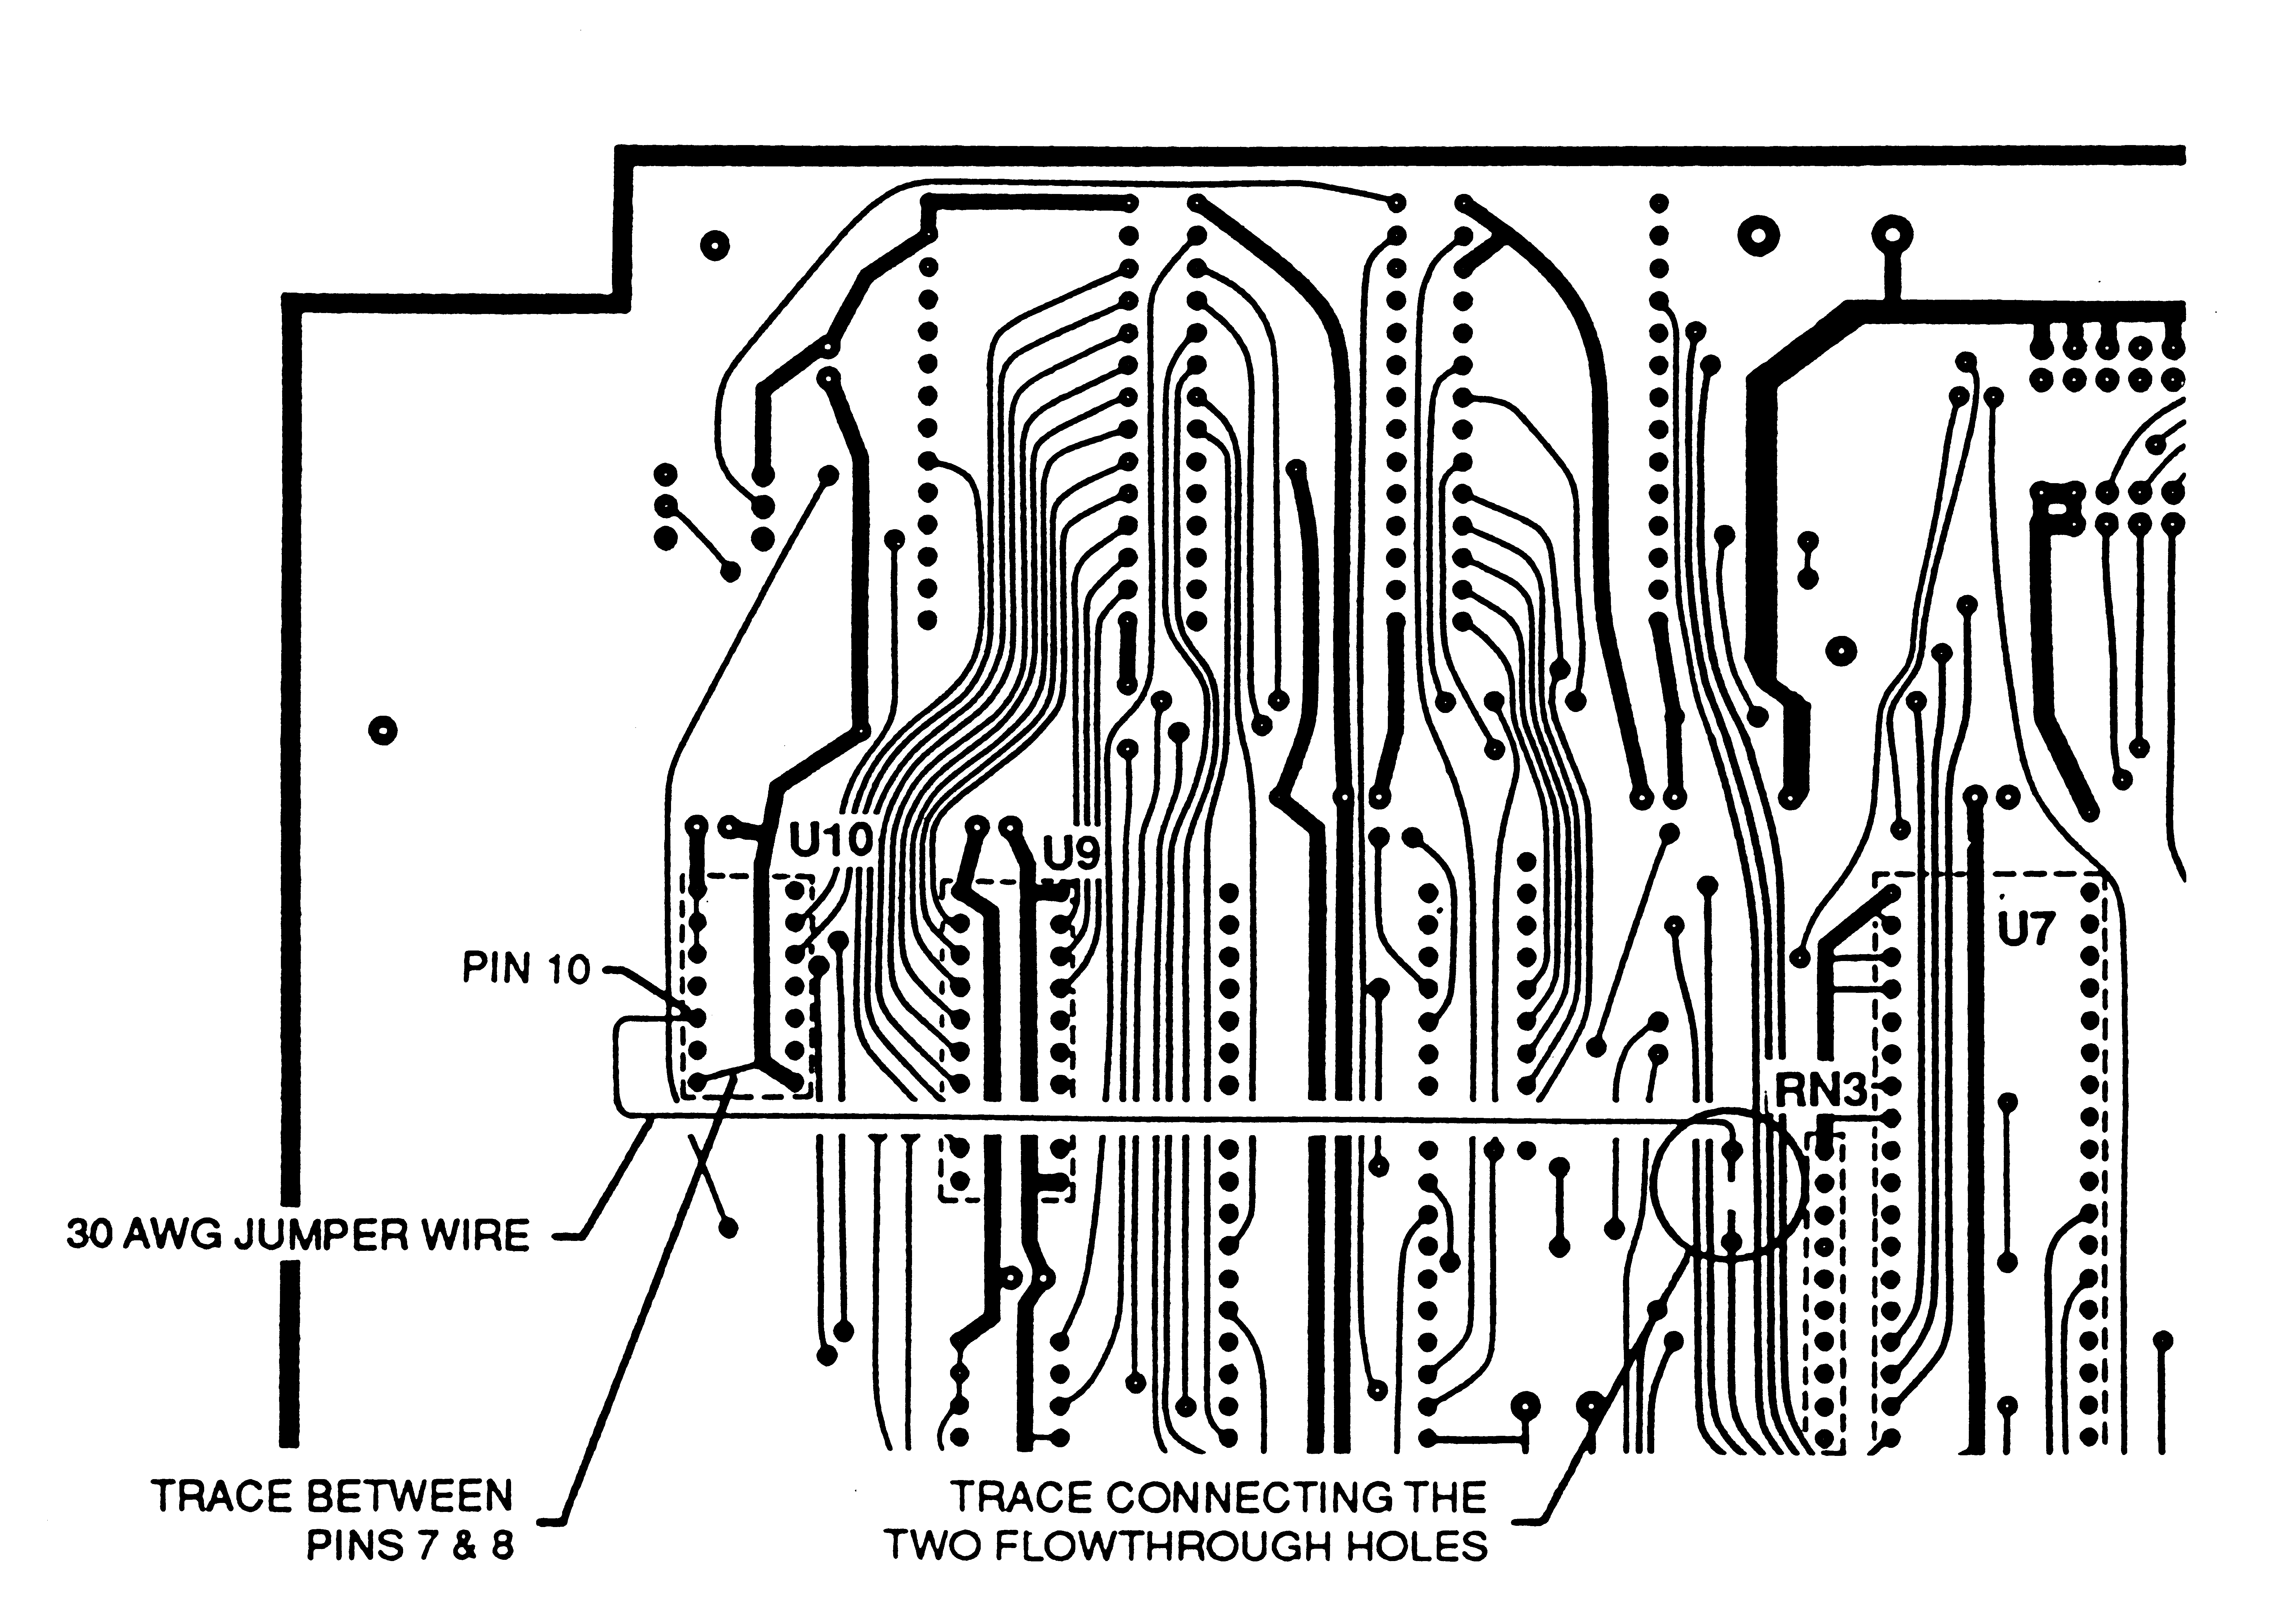
Figure 2. KCU Board Modifications

PROCEDURE (continued)
4. Turn the KCU over and remove the four phillips screws holding the bottom cover to the KCU chassis. Remove the bottom cover. It is not necessary to remove the PC boards from the chassis.
5. Refer to Figure, cut the trace connecting the two flowthrough holes. These holes are located next to RN3.
6. Solder a 30 AWG jumper wire between the top flowthrough hole and pin 10 of U10, as shown in Figure 2.
7. Examine the trace between pins 7 and 8 of U10. If this trace has been cut, there will be a wire jumper between pins 8 and 14. Remove the jumper between pins 8 and 14 and solder a 30 AWG wire between pins 7 and 8.
8. Replace the bottom cover on the KCU chassis. Insert and tighten the four phillips screws to secure the cover to the chassis.
9. Set the KCU upright in its normal operating position.
10. Replace the PROM cover. Insert and tighten the two phillips screws. Note, using too much forward pressure when installing the screws could damage the KCU bottom cover. Reconnect the cables and turn on the power.

